

Asia-Pacific International University
Faculty of Information Technology Course Info:
IT 483 – System Development Project 1

Senior Project Report Proposal
Topic: Online Cake Shop

Student Information:

Chan Thar Htoo

202000158

Table of Contents
- Introduction 3
  - Introduction Project 3
  - Titles 4
  - Project Objective 4
    - General Objectives 4
    - Specific Objectives 4
- Related Works 5
  - Related studies 5
- Preliminary Investigation 6
  - Company Profile 6
  - Organizational Chart 7
  - Statement of the Mission/Goal of the Organization 7
  - Project Request………………………………………………………………………………… 7
  - Description of the Problem 7
  - Project Scopes and Constrain 8
  - Expected Business Benefits 9
  - Expected Systems Capabilities 9
  - Project Planning 10

- Introduction
  - Introduction Project
Introduction In today's digital age, online businesses have become essential for reaching a wider customer base and ensuring convenience for consumers. The proposed senior project aims to develop an "Online Cake Shop App" to address the needs of a local bakery. This project holds significance for both the bakery and its potential customers, offering a streamlined platform for ordering cakes and related products. In the ever-evolving landscape of information technology, the development of practical and impactful applications is paramount. This senior project proposal introduces the concept of an "Online Cake Shop Application" with a unique and personal touch – it is designed specifically for my sister's bakery, named "Sister's Bakery."
In recognition of the modern customer's need for convenience and time-saving solutions, this project aims to create an online platform tailored to the specific needs of the bakery. The goal is to streamline the ordering process, enhance customer experience, and promote the bakery's offerings in the digital space.
In a world where every moment is an opportunity for celebration, the joy of sharing a beautifully crafted birthday cake or confection should be accessible to everyone, without the hurdles of transportation or the constraints of time. My senior project proposal is driven by a profound aspiration: to redefine the way people experience the delight of ordering cakes and confections for special occasions. Our primary motivation lies in presenting customers with an ingenious and user-friendly platform for cake delivery, one that fundamentally transforms the art of celebration.

  - Titles
Online Cake Shop

  - Project Objective
    - General Objectives
User-Friendly Interface is like design an intuitive and user-friendly interface that ensures customers can easily navigate the app. Develop a comprehensive digital catalog that displays a wide range of cakes and related products. Include high-quality images and detailed descriptions for each item. Secure Payment Gateway Integrate a secure payment gateway to facilitate online transactions, ensuring the safety of customer payment information. Order management system is like creating a backend system for the bakery staff to efficiently process and fulfill customer orders. This system should include features like order tracking and notifications.
The general objective of this project is to create a user-friendly Online Cake Shop App that enhances the bakery's market presence and improves customer satisfaction by providing a convenient and efficient way to order cakes and pastries.
- Market Research and Analysis
like the way of Conduct thorough market research to identify the target audience, competitors, and market trends in the bakery and online food delivery industry.

- Define Features and Functionality.
Determine the specific features and functionality of the Online Cake Shop App, such as user registration, menu display, order placement, payment processing, and order tracking.
- Backend Development.
Build the backend of the app, including database setup, server configuration, and API development for smooth data flow and communication between the app and the bakery.
    - Specific Objectives
- Develop a mobile application that allows users to browse the bakery's product catalog.
- Implement a secure and user-friendly registration and login system for customers.
- Enable customers to customize cake orders with various options like flavor, size, and decoration.
- Implement a secure payment gateway for online transactions.
- Provide an order tracking system for customers to monitor the status of their orders.
- Administer an inventory management system for the bakery to track product availability.
- Related Works
    - Related studies
Related Works this section will provide a concise overview of similar online cake ordering solutions, highlighting their features and functionalities. The "Related Works" section helps provide context for my project by showing what already exists in the field, what has been successful, and what areas may need innovation or improvement in my own Online Cake Shop App.

When conducting related studies for my senior project on an online cake app system, it's important to review relevant literature and research that can provide insights, best practices, and trends in the field of online cake ordering and e-commerce systems. I try to read some article and website for example below:
E-commerce and Online Food Ordering Trends: I just researched the latest trends in the e-commerce and online food ordering industries, as they are closely related to my project online cake app.
User Experience (UX) Design for E-commerce: I just read articles and research papers that discuss UX design principles for e-commerce websites and apps, as a user-friendly interface is crucial for my project's success.
Payment Processing and Security: Explore research on secure payment processing in online platforms, including various payment gateways and encryption methods. Payment processing and security are of paramount importance in the development of an online cake ordering app or any e-commerce platform. Ensuring the safety and trustworthiness of financial transactions is critical for both my business's reputation and the protection of my customers.
Menu Management and Customization: Investigate how other food delivery apps manage their menus and allow for customization of orders. When developing an online cake ordering app, I can take inspiration from how other food delivery apps manage their menus and allow for customization of orders.
- Preliminary Investigation
3.1 Company Profile
Company Profiles

Organizations: Sweet Sisters Bake Shop
Name of Client: Naw Eh Thaw
Address: 1844 7th St, Rock Island, IL 61201, United States
Contact’s Phone Number: +1-309 7518310
Contact’s Email address: nawehthaw1990@gmail.com

3.2 Organizational Chart
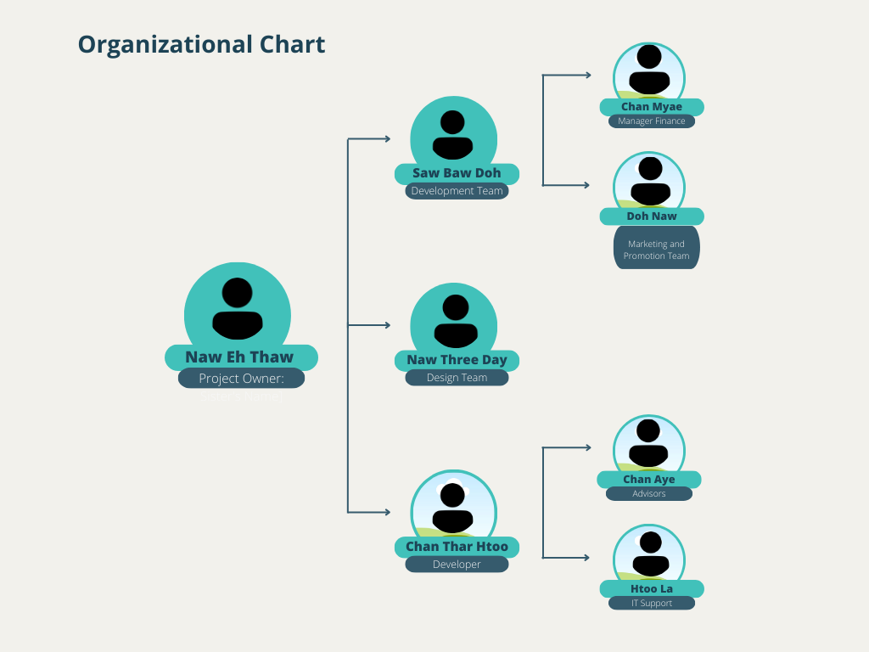

3.3 Statement of the Mission/Goal of the Organization

At Sweet Sister Bake Shop, our mission is to craft delightful, handcrafted cakes and pastries that go beyond mere confections – they are a symbol of love, celebration, and joy. Our purpose is to be the trusted source for creating memorable moments by offering delectable and visually stunning cakes, pastries, and sweet treats for our valued customers. This mission statement not only outlines the purpose and values of Sweet Sister Bake Shope but also serves as a guiding principle for the organization, inspiring every member of the team to contribute to the company's success and the happiness of its customers.
3.4 Project Request
The project was initiated in response to the increasing demand for online cake orders, driven by changing consumer preferences and the need for contactless transactions.
3.5 Description of the Problem
The bakery faces challenges in efficiently managing online orders, tracking inventory, and providing a seamless customer experience. The existing manual system is prone to errors and does not meet the growing demand for online orders. For example, like limited customer reach.
3.6 Project Scopes and Constrain
Project Scopes.
- Development of the Online Cake Shop App
- Integration with existing bakery process
- Secure online payment system
- User registration and login functionality
- Inventory management system
Project Constraints
- Limited Budget and Resources.
understand that our organization operates with a limited budget and resources. This constraint necessitates a careful allocation of funds and efficient resource utilization throughout the project.
- Time Project Timeline:
Time is of the essence in the successful execution of my project. The project timeline is constrained by the need to meet market demands and competitive pressures. I will adopt agile project management practices to accommodate changes, optimize development cycles, and ensure timely project delivery.
3.7 Expect Business Benefits
For my project aims to bring the following benefit for Sweet Sister Bake shop online app:
- Increase online sales.
- Enhanced customer satisfaction
- Streamlined order management.
- Improved inventory control
- Data driven decision making.
3.8 Expected System Capabilities:
For my project of the online cake shop app is expected to have the following capabilities.
- User friendly interface
- Secure payment processing
- Real-time order tracking
- Customizable cake orders
- Inventory status updates
3.9 Planning
- I just created a time management schedule for my online cake app project is crucial for staying organized and ensuring that I meet my project deadlines. Below is a sample schedule to help with my project effectively.

Plan 1: Project Initiation (1 week)
Day 1-2: Define project objectives, goals, and scope.
Day 3-4: Conduct market research and competitor analysis.
Day 5-6: Develop a project charter and secure necessary resources.
Day 7: Finalize the project initiation documentation.

Plan 2: Planning (2 weeks)
Week 1:
Day 1-2: Create a project plan, including a detailed scope statement and work breakdown structure (WBS).
Day 3-4: Identify and engage key stakeholders.
Day 5: Develop a project schedule with milestones.
Day 6-7: Allocate resources and budget for the project.
Week 2:

Day 1-2: Create a risk management plan.
Day 3-4: Develop a quality management plan.
Day 5-6: Finalize the project plan, including all documentation.
Day 7: Review and gain approval for the project plan.
Plan 3: Design and Development (6 weeks)
Weeks 3-4:
Days 1-14: Design the user interface and app architecture.
Weeks 5-6:
Days 15-42: Develop the online cake app based on the design.
Plan 4: Testing and Quality Assurance (4 weeks)
Week 7-10:
Days 1-28: Conduct thorough testing, including functional, usability, and performance testing.
Address and resolve any identified issues.
Plan 5: Deployment (2 weeks)
Week 11-12:
Days 1-14: Prepare for the app's launch, including server setup, data migration, and final testing in a production-like environment.
Plan 6: Marketing and Promotion (8 weeks)
Weeks 13-20:
Days 1-56: Develop and implement a marketing strategy, including social media campaigns, email marketing, and partnerships.
Plan 7: Operations and Maintenance (Ongoing)
Week 21 and beyond:
Ongoing: Monitor app performance, gather user feedback, and implement updates and improvements.
Plan 8: Project Closure (1 week)
Week 22:
Days 1-7: Complete all project documentation, conduct a project review, and obtain formal project closure approval.

